**Session-21 Assignment**

**Name:-** Aryan Dilipbhai Langhanoja

**Enroll No:-** 92200133030

**AIM**: To understand various linear and non-linear opamp applications.

**Objective:**

1. To understand various linear-nonlinear applications using opamp.
2. To understand working of active filter circuits and linear mode of opamp
3. To understand nonlinear opamp circuits like square wave oscillator, comparator and inverting Schmitt trigger circuits.

**Apparatus:**

1. DC power Supply
2. OPAMP uA741.
3. Resistor

**Task-1: First order Butterworth low pass filter Circuit**

**Circuit diagram:**

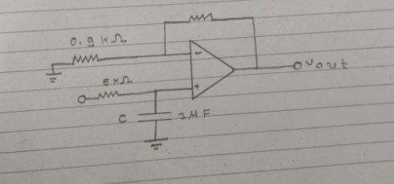

**Task-2: Square-wave oscillator Circuit**

**Circuit diagram:**

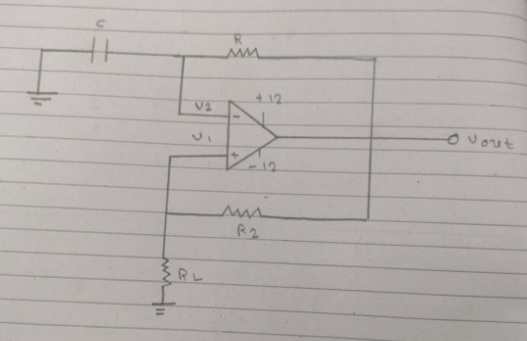

**Task-3: Comparator Circuit**

**Circuit diagram:**

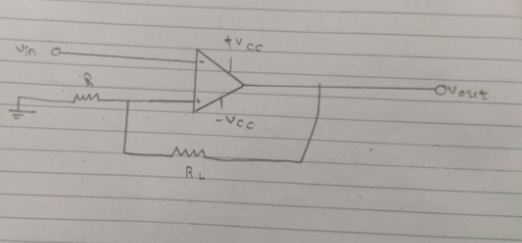

**Task-4: Inverting Schmitt Trigger Circuit**

**Circuit Diagram:**

